Mail Server Domain

📬 What is a Mail Server Domain?
# Source: Chatgpt (GPT-5-Mini) at [1/21/2026]
A mail server domain is the domain name used by an email server (Mail Servers) to send, receive, or route emails.
It’s part of the email address that tells mail systems where to send the message — like the "postal city" in an address.

🧠 Example Breakdown:
# Source: Chatgpt (GPT-5-Mini) at [1/21/2026]
Email address:
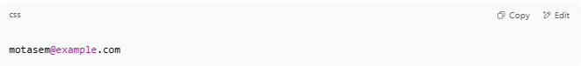
motasem@example.com

- motasem → local part (username)
- example.com → mail server domain
This means:
📨 "Send mail to the user motasem at the mail server for example.com"

🛠️ How It Works in Practice:
# Source: Chatgpt (GPT-5-Mini) at [1/21/2026]
When an email is sent to motasem@example.com, your email provider looks up DNS records for:
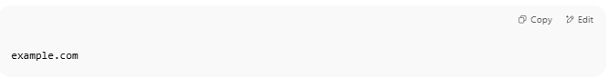
example.com

It looks for MX (Mail eXchange) records that point to the real mail server hostname, like:
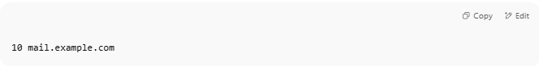
10 mail.example.com

Then the email is delivered to that server.

🔁 Example Flow
# Source: Chatgpt (GPT-5-Mini) at [1/21/2026]
- You send email to user@gmail.com
- The mail server looks up gmail.com's MX record:
  - gmail.com. MX 10 alt1.gmail-smtp-in.l.google.com.
- Email is routed to that mail server domain

Great question! Here's what happens step by step after the email is routed to Gmail's mail server domain:

✉️ Full Email Delivery Flow:

1. You send an email to: user@gmail.com
# Source: Chatgpt (GPT-5-Mini) at [1/21/2026]
Your email client or app (like PHPMailer, Outlook, or Gmail) connects to your SMTP server to send the message.

2. Your SMTP server looks up MX record for gmail.com
# Source: Chatgpt (GPT-5-Mini) at [1/21/2026]
MX record result (simplified):
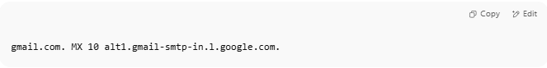
gmail.com. MX 10 alt1.gmail-smtp-in.l.google.com.

This means: “Send the email to Gmail's mail server at alt1.gmail-smtp-in.l.google.com.”

3. Your server connects to Gmail’s SMTP server
# Source: Chatgpt (GPT-5-Mini) at [1/21/2026]
Your mail server (MTA) opens an SMTP connection to:
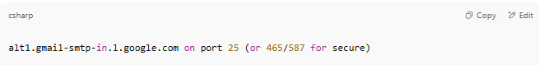
alt1.gmail-smtp-in.l.google.com on port 25 (or 465/587 for secure)

4. Gmail's mail server receives the message
# Source: Chatgpt (GPT-5-Mini) at [1/21/2026]
- Gmail’s mail server checks the message:
  - Is the domain SPF/DKIM/DMARC valid?
  - Is the sender on a spam blacklist?
  - Does the recipient exist?
  - Is there a virus or malware?
If it passes all checks → Gmail accepts the email.

5. Gmail stores the email in the user's mailbox
# Source: Chatgpt (GPT-5-Mini) at [1/21/2026]
The message is saved in the user’s Gmail account:
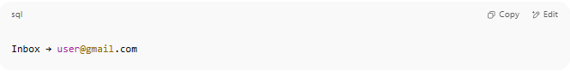
Inbox → user@gmail.com

Now it's ready for the user to read.

6. User reads email using IMAP or Gmail web interface
# Source: Chatgpt (GPT-5-Mini) at [1/21/2026]
- The user logs into Gmail (web or app)
- The Gmail IMAP server or webmail interface displays the message
- The email is now delivered and visible

🔁 Recap Diagram:
# Source: Chatgpt (GPT-5-Mini) at [1/21/2026]
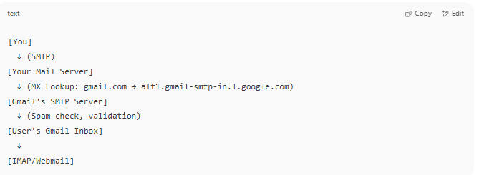

[You]
↓ (SMTP)
[Your Mail Server]
↓ (MX Lookup: gmail.com → alt1.gmail-smtp-in.l.google.com)
[Gmail's SMTP Server]
↓ (Spam check, validation)
[User's Gmail Inbox]
↓
[IMAP/Webmail]

✅ Summary
# Source: Chatgpt (GPT-5-Mini) at [1/21/2026]
After routing to Gmail's mail server:
- Gmail receives the message
- Validates and filters it
- Stores it in the recipient’s mailbox
- Makes it accessible via webmail or IMAP

📡 Examples of Real Mail Server Domains:
# Source: Chatgpt (GPT-5-Mini) at [1/21/2026]
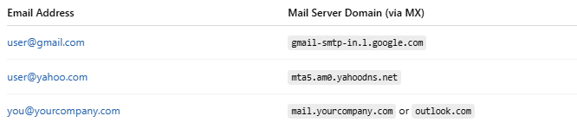

Email Address | Mail Server Domain (via MX)
user@gmail.com | gmail-smtp-in.l.google.com
user@yahoo.com | mta5.am0.yahoodns.net
you@yourcompany.com | mail.yourcompany.com or outlook.com

🧾 Summary
# Source: Chatgpt (GPT-5-Mini) at [1/21/2026]
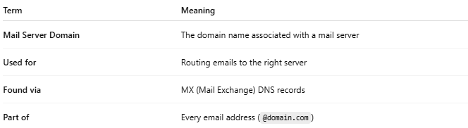

Term | Meaning
Mail Server Domain | The domain name associated with a mail server
Used for | Routing emails to the right server
Found via | MX (Mail Exchange) DNS records
Part of | Every email address (@domain.com)

